Release Notes:

December 2011 -- update oma for newer versions of Xcode

Implement source control with subversion

Notes:

svn does not handle resource forks

the old main.rsrc had no information in it

to move things out of the resource fork:

cp main.rsrc/..namedfork/rsrc main.rs

then it's OK to rename min.'s to main.rsrc

need to change ./subversion/config so that it does not ignore ".a" files

.rtfd files (text edit with pictures pasted in don’t play nice with svn, so changed release notes to a word file – probably want to save as pdf before a release

v 2.2.0 (Not yet released)

**Bugs fixed:**

Dragging a macro file onto a window now works even if there is a prefix specified.

Don't get as many "Possible Parameter Mismatch" errors when loading up hi-res images.

Now reads color tiff images with 16 bits/color properly.

ROTRGB -- bug fixed that could crash the program.

Changed title of images displayed by dragging to be the last part of the name, rather than starting with the whole file path

**LOOKUP** command now does more error checking.

**GETFUNCTION** prints out more function info.

Fixed bug that would sometimes cause **GTEMP** to crash.

**BLOCKRGB** now finds the new min/max

Fixed a problem in arithmetic assignment commands where an integer variable would get strange values when set to a floating point expression

**Bugs noted but not fixed:**

**GWIND** doesn't work, but is still described in the help - search for getwindowdata(

**Column plot doesn't work right for window that is scaled down to fractional size (fixed I think)**

**New Window and Color Image Tools:**

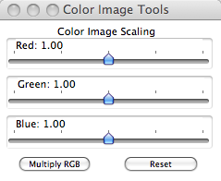

**New Commands:**

**ABELPREP** clip_value [fill_value]

Finds the maximum pixel value along horizontal lines in the image. If that

maximum is < clip_value, the entire horizontal line is set to fill_value.

Default for fill_value is 0.

**ABELRECT** rec_width [rec_y0 rec_y1]

Sets the rectangle (of width rec_width) according to the centroid of the image.

If rec_y0 and rec_y1 are omitted, they are taken to be the top and bottom of the image

**CLIPBOTTOM** clip_value

For the current image, set pixels whose value is < clip_value to be equal to clip_value.

**CLIPFBOTTOM** clip_fraction

For the current image, set pixels whose value is < clip_fraction*image_max to be equal to clip_fraction*image_max.

**FINDBAD** Counts

Searches the current image buffer for pixels whose value is more than "Counts" above that of its

nearest eight neighbors. Those pixels are tagged as hot pixels.

**CLEARBAD**

Sets pixels tagged as bad to the value of their 8 nearest neighbors. This will not work well if

there are contiguous bad pixels. For that, consider using the FILBOX or FILMSK commands.

**READBAD filename**

Read in bad pixel data from a text file.

Format is:

# of bad pixels

detector_width detector_height

bad_pix1_x bad_pix1_y

bad_pix2_x bad_pix2_y

.

.

.

**WRITEBAD filename**

save bad pixel data to a text file.

Format is:

# of bad pixels

detector_width detector_height

bad_pix1_x bad_pix1_y

bad_pix2_x bad_pix2_y

.

.

.

**DZRGB** npix

Using the size specified by the current rectangle, zoom in on an area of an RGB image

centered on the cursor. Zoom factor is npix (integer). This is good for getting a

close-up of a sub-region of an image. This is the color image version the DZOOM command.

**SBIG command_string [parameters]**

command_string specifies the SBIG command (listed below).

Only the first 3 characters of SBIG commands matter

The values for parameters depend on the particular command.

**SBIG command_strings:**

**EXPosure** exposure_time

Specify exposure_time in seconds. Does not take an image.

**FILter**

Specify which fillter to use.

**TEMperature**

Specify set temperature of the CCD in degrees C.

**DISconnect**

Close the device and driver.

**STAtus**

Print out CCD info, temperature, exposure, etc.

**ACQuire**

Get an image using the current settings.

**AINBURST** num_channels, num_points, rate

Read Analog input on a LabJack U12 in burst mode.

num_channels: must be 1, 2 or 4

num_points: the number of points acquired for each channel

rate: the scan rate (Hz)

restrictions:

num_channels*rate must be 400-8192.

num_channels*num_points must be 1-4096

Analog channels 0, 0 and 1, or 0, 1, 2, and 3 are sampled for num_channels equal to 1, 2, or 4 respectively.

**SHELL** shell_command

Opens a pipe to a shell and sends along the command. Output from the command is echoed to the command window.

**CAPTURE** file_name

Uses libgphoto2 calls to capture and download an image from a digital camera that is recognized by libgphoto2 (and supports capture).

**CAMLISTSETTINGS**

Uses gphoto2 calls to list the settings of the camera that can be set, along with their current values.

**CAMGETSETTING** name

Uses gphoto2 calls to list the current value of the specified setting, along with the allowed values for resetting it.

**CAMSETSETTING**  name new_setting_value

Uses gphoto2 calls to reset the value of the specified setting to the new value. For a listing of valid setting values, use the GETCAMSETTING command.

**CAMCLOSE**

Disconnects from the digital camera accessed through gphoto2.

**DCRAWARGS** [arguments]

Allows the user to specify the arguments passed to the dcraw routine, which decodes camera raw files to OMA format. Omitting the argument lists the allowed arguments and gives the current argument settings. The filename field is ignored.

**DOC2RGB** c1 c2 c3 c4

Treat the image in the current image buffer as a raw document (output from the dcraw routine with options -d or -D selected)

and convert it to an RGB image. This is assumed to have a 2 x 2 color matrix of R G B values in a Bayer pattern.

c1 - c4 have values 0, 1 or 2, corresponding to red, green, and blue. For example if Bayer Matrix is

G B

R G

c1 - c4 should be 1 2 0 1

Appropriate values depend on the specific camera. (See the output from the GETRGB command.)

**New features for command interpretation:**

**%p** Filled in with the "save data" prefix

**%q** Filled in with the "get data" prefix

**Modified Commands**

**RECTANGLE** [ulx uly lrx lry]

Specify a rectangle that calculations are to be done on. The arguments are upper

left x coordinate; upper left y coordinate; lower right x; lower right y. If no arguments are given, the current rectangle is echoed to the terminal. The coordinates of the current rectangle are returned in the command arguments.

**RECTCENTER** n m

Select rectangle of size n x m about center of image. The coordinates of the rectangle are returned in the command arguments.

**INTEGRATE** direction_flag selection_flag do_average

Sum up the data in the horizontal ( direction_flag=0 ) or vertical (direction_flag=1)

direction. The two-dimensional image becomes a single line. If selection_flag=1,

the subset of the image specified by the selection rectangle is used. Possible cases

are:

direction_flag = 1 The result is an array in x; sum in y direction

direction_flag = 0 The result is an array in y; sum in x direction

selection_box = 1 A selection box specifies what region to sum

selection_box = 0 Sum all channels or tracks (columns or rows)

do_average = 1 Average along the integrate direction (divide by box size in integration direction).

do_average = 0 Just sum, don't average.

**INTFILL** direction_flag selection_flag do_average

As above, but a two-dimensional image is formed by duplicating the summed (or averaged) values.

**New Menu Command:**

**Plot Both (Cmnd 3)**

v 2.1.4

What's New:

**CoverFlow**

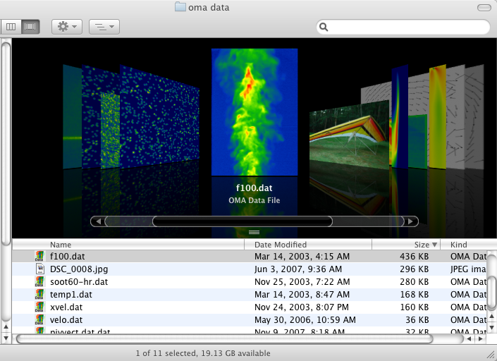

For Leopard (Mac OS 10.5.0 or greater) there is now a QuickLook Plugin that allows the user to browse OMA files in CoverFlow from the Finder. Supported file types include OMA data files as well as PIV files. Hit the space bar for a more detailed Preview.

To install the QuickLook Plugin (MacOS 10.5 only), double click "Install QuickLook for OMA files." The installer will put the plugin (a file named "omalook3.qlgenerator") in the folder /Library/Quicklook.

**Drag and Drop**

Now you can drag and drop files onto any OMA window to open them. Note that dropping tiff, jpeg, or macro files onto the command window will display them there.

**Automatic Display**

When a data file is opened by double clicking, dragging and dropping to an oma window, or dragging onto the oma icon, the files will be opened AND displayed.

**New Commands**

SATIFFSCALED min max <filename>

Convert image to 8 bit and save as a Greyscale TIFF file. Uses the specified min and max for scaling rather than the min and max of the image in the buffer. Results will be between 0 - 255. Depending on min and max, the image may be clipped or the full 8-bit dynamic range may not be used.

PIVUODETECT

A PIV command that implements the Universal Outlier detection algorithm of J. Westerweel and F. Scarano "Universal Outlier Detection for PIV data" Experiments in Fluids [39]:1096-1100 (2005).

RNDUP

Round the DATAWORD values UP to the nearest integer value.

RNDOFF

Round the DATAWORD values Down to the nearest integer value.

TSMOOTH

Smooth radius based on x_dim = Temp[0], y_dim = Temp[1]

This is a function that enables (Rectangular) smoothing of an image, with variable filter size. It works basically like SMOOTH 13 13, say, but it takes the x_dim and y_dim locally based on the values in the Temporary buffers T[0] and T[1]. It has been used to variably smooth an image based on the local length scale which was modelled.

PIXVALUE x y

Prints the value of the pixel at location x,y (i.e, at column x and row y). The upper left of an image is at 0,0.

command_return_1 is the value.

**Changes/Corrections to Current Functions**

Changed the way menu commands work for saving a rectangle -- allow the menu command to use the currently defined

rectangle rather than having to specifically draw one on the screen. Added error checking to be sure current rectangle is valid.

Corrected problem when reading in TIFF images with 16 bits per sample into intel machines. Also removed the

scale factor of 2 for 16 bits per sample data (not needed with new floating point default data type).

GTIFF command now returns the number of samples per pixel as variable command_return_1.

AOUTPUT v1 v2 [v3 v4]

Sends voltages to D/A converters 0 and 1 on a Labjack USB analog/digital I/O device.

If a Labjack U3 is present, v1 and v2 are sent to it.

If there is no U3 but there is a Labjack U12, v1 and v2 are sent to the U12.

If both U3 and U12 Labjacks are present and all 4 voltages are given, v1 and v2 are sent to the U3 and v3 and v4 are sent to the U12.

BIT8 [min] [max]

Converts the file in the OMA image buffer to have a dynamic range of 0 to 255. That is, 8 unsigned bits per pixel. This conversion is automatically done before saving the image buffer as a TIFF image. If the optional min and max are specified, they are used for the scaling rather than the min and max of the current image buffer.

Fixed bug in ROTCRP command that had it going completely off the rails.

OMA is now tolerant of renaming the application. It used to be that if the application was renamed, various resources (palettes, help files, etc. were not found. That should be fixed now.